CCAS 4.3
Software Engineering

Clothing E-Commerce

Presented to: Dr. Samar
Team: Youssef Mokhtar, Omar salah, Abdelrahman Walid, Amr salah

Table of Csontents
2 Functional Requirements 4
2.1 Must have requirements 4
2.2 Should have requirements 5
2.3 Could have requirements 5
2.4 Won’t have requirements 6
3 Non-Functional Requirements 6
4 Use Case Scenarios 7
4.1 Use Case 1: User Purchases a Product 7
4.2 Use Case 2: Admin Manages Product 7
4.3 Use case 3: User Tracks Order 7
5 ERD Diagram 8
6 Relational Database Schema 9
7 SQL Queries 10
7.1 User 10
Explanation 10
7.2 Address 10
Explanation 11
7.3 Payment 11
Explanation 11
7.4 Orders 11
Explanation 12
7.5 Tracking_detail 12
Explanation 12
7.6 Category 12
Explanation 13
7.7 Product 13
Explanation 13
7.8 Order_Product 13
Explanation 14
7.9 Discount 14
Explanation 14
7.10 Cart 15
Explanation 15
7.11 Cart_Product 15
Explanation 15
7.12 Review 16
Explanation 16
7.13 Admin 16
Explanation 17
8 Website Prompt 18
9 Website Screenshots 18
10 Website Testing 23
10.1 Manual Testing: 23
10.2 Automatic Testing: 23
11 GitHub Link 24

Functional Requirements

Must have requirements

REQ ID | Requirement Name | Description | Priority
REQ_001 | User Registration | The system must allow users to create an account using email or phone number. | Must Have
REQ_002 | User Login & Logout | The system must allow registered users to securely log in and log out. | Must Have
REQ_003 | Product Browsing | The system must allow users to browse products by category, gender, and collection. | Must Have
REQ_004 | Product Search | The system must allow users to search for products using keywords. | Must Have
REQ_005 | Product Details View | The system must display product details including images, price, size, color, and description. | Must Have
REQ_006 | Shopping Cart | The system must allow users to add, update, and remove items from the cart. | Must Have
REQ_007 | Checkout Process | The system must allow users to enter shipping details and confirm checkout. | Must Have
REQ_008 | Payment Processing | The system must support online payment methods (cards, wallets). | Must Have
REQ_009 | Order Confirmation | The system must generate an order confirmation after payment. | Must Have
REQ_010 | Order History | The system must allow users to view past orders. | Must Have
REQ_011 | Admin Product Management | The system must allow admins to add, edit, or delete products. | Must Have
REQ_012 | Security | The system shall encrypt user and payment data using standard protocols. | Must Have
REQ_013 | Data Privacy | The system shall comply with data protection regulations. | Must Have

Should have requirements

REQ ID | Requirement Name | Description | Priority
REQ_014 | Wishlist | The system should allow users to save products to a wish list. | Should Have
REQ_015 | Order Tracking | The system should allow users to track order status. | Should Have
REQ_016 | User Profile Management | The system should allow users to edit profile details and addresses. | Should Have
REQ_017 | Discount Codes | The system should support promo codes and discounts. | Should Have
REQ_018 | Reviews & Ratings | The system should allow users to rate and review products. | Should Have

Could have requirements

REQ ID | Requirement Name | Description | Priority
REQ_019 | Product Recommendations | The system could recommend products based on user behavior. | Could Have
REQ_020 | Multi-Language Support | The system could support multiple languages. | Could Have
REQ_021 | Live Chat Support | The system could provide live customer support chat. | Could Have

Won’t have requirements

REQ ID | Requirement Name | Description | Priority
REQ_022 | Physical Store Integration | The system will not integrate with physical retail stores in this version. | Won’t Have

Non-Functional Requirements

REQ ID | Category | Description
REQ_023 | Performance | The system shall load pages within 3 seconds under normal conditions.
REQ_024 | Scalability | The system shall handle increasing users and products efficiently.
REQ_025 | Availability | The system shall be available 99.5% of the time.
REQ_026 | Usability | The system shall provide an intuitive, mobile-friendly UI.
REQ_027 | Compatibility | The system shall support major browsers and mobile devices.

Use Case Scenarios

Use Case 1: User Purchases a Product
Item | Description
Actor | Customer
Related REQs | REQ_001, REQ_002, REQ_006, REQ_007, REQ_008, REQ_009
Scenario | User logs in, browses products, adds an item to the cart, checks out, and receives confirmation.

Use Case 2: Admin Manages Product
Item | Description
Actor | Admin
Related REQs | REQ_011
Scenario | Admin adds, updates, or removes products from the catalog.

Use case 3: User Tracks Order
Item | Description
Actor | Customer
Related REQs | REQ_013
Scenario | User views order history and checks delivery status.

ERD Diagram
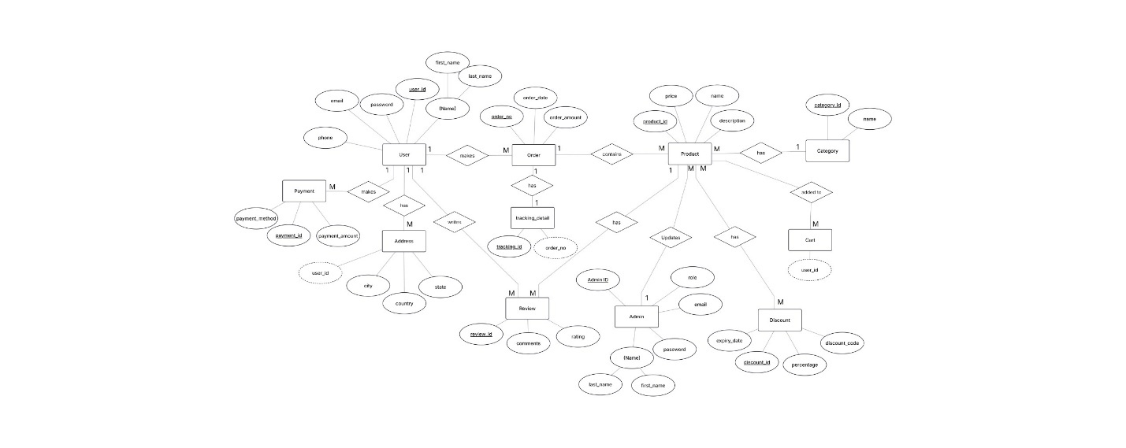

Relational Database Schema

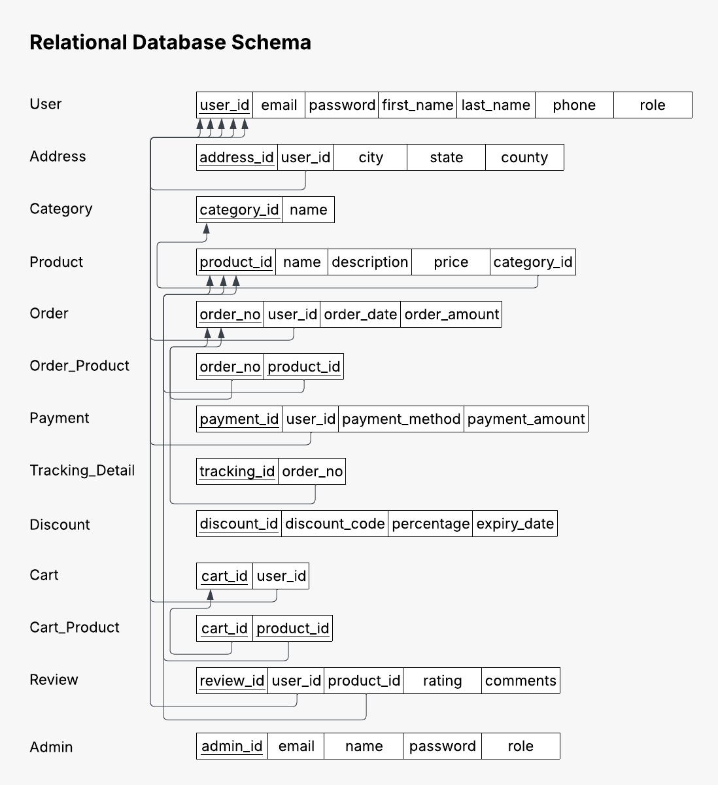

SQL Queries

User
CREATE TABLE User (
user_id INT NOT NULL,
first_name VARCHAR(50),
last_name VARCHAR(50),
email VARCHAR(100),
password VARCHAR(100),
phone VARCHAR(20),
role VARCHAR(20),
CONSTRAINT User_PK PRIMARY KEY (user_id),
CONSTRAINT User_email_UQ UNIQUE (email)
);

Explanation
We created a user table that contain user_id (does not allow NOT NULL values and only accept integers), first, last name (each take up to 50 characters), email, password (each take up to 100 characters), phone no. and role (each take up to 20 characters). Then we defined that the user_id is the PRIMARY_KEY and we made sure that each email for each user is unique. In a whole, this table takes all the information required to be used in order to create an account.

Address
CREATE TABLE Address (
address_id INT NOT NULL,
user_id INT NOT NULL,
city VARCHAR(50),
state VARCHAR(50),
country VARCHAR(50),
CONSTRAINT Address_PK PRIMARY KEY (address_id),
CONSTRAINT Address_User_FK FOREIGN KEY (user_id)
REFERENCES User(user_id)
);

Explanation
Created an Address table that contains address_id, user_id (both does not allow NOT NULL values and only accept integers), city, state and country (each take up to 50 characters). Then we made the address_id the primary key and created a relationship between this table and the users table (user_id) using a foreign key.

Payment
CREATE TABLE Payment (
payment_id INT NOT NULL,
user_id INT NOT NULL,
payment_method VARCHAR(50),
payment_amount DECIMAL(10,2),
CONSTRAINT Payment_PK PRIMARY KEY (payment_id),
CONSTRAINT Payment_User_FK FOREIGN KEY (user_id)
REFERENCES User(user_id)
);

Explanation
Created a Payment table that contains payment_id, user_id (both does not allow NOT NULL values and only accept integers), payment_method (takes up to 50 characters) and payment_amount (takes up to 10 digits and only 2 decimal points). Then, we defined payment_id as the primary key. Lastly, we initiated a relationship between this table and user table and the foreign key is user_id.

Orders
CREATE TABLE Orders (
order_no INT NOT NULL,
user_id INT NOT NULL,
order_date DATE,
order_amount DECIMAL(10,2),
CONSTRAINT Orders_PK PRIMARY KEY (order_no),
CONSTRAINT Orders_User_FK FOREIGN KEY (user_id)
REFERENCES User(user_id)
);

Explanation
We created orders table that contains order no., user_id (both does not allow NOT NULL values and only accept integers), order_date (stores the date of the order), order_amount(takes up to 10 digits and only 2 decimal points). Then, we defined order_no. as the primary key. Lastly, we initiated a relationship between this table and the user table and he foreign key is user_id.

Tracking_detail
CREATE TABLE Tracking_Detail (
tracking_id INT NOT NULL,
order_no INT NOT NULL,
CONSTRAINT Tracking_PK PRIMARY KEY (tracking_id),
CONSTRAINT Tracking_Order_FK FOREIGN KEY (order_no)
REFERENCES Orders(order_no)
);

Explanation
We created a Tracking_Detail table that consists of tracking_id and order_no. (both does not allow NOT NULL values and only accept integers). We chose the tracking_id as the primary key. Lastly, we established a relationship between this table and orders table and we used order_no. as the foreign key.

Category
CREATE TABLE Category (
category_id INT NOT NULL,
name VARCHAR(50),
CONSTRAINT Category_PK PRIMARY KEY (category_id)
);

Explanation
We created a category table that contains of category_id (does not allow NOT NULL values and only accept integers) and name (takes up to 50 characters). We chose the category_id as the primary key.

Product
CREATE TABLE Product (
product_id INT NOT NULL,
name VARCHAR(100),
description VARCHAR(255),
price DECIMAL(10,2),
category_id INT NOT NULL,
CONSTRAINT Product_PK PRIMARY KEY (product_id),
CONSTRAINT Product_Category_FK FOREIGN KEY (category_id)
REFERENCES Category(category_id)
);

Explanation
We created a product table that contains product_id , category_id (both does not allow NOT NULL values and only accept integers), name (takes up to 100 characters), description (takes up to 255 characters) and price (takes up to 10 digits and only 2 decimal points). We chose product_id as the primary key. Lastly, we created a relationship between this table and category table and used category_id as the foreign key.

Order_Product

CREATE TABLE Order_Product (
order_no INT NOT NULL,
product_id INT NOT NULL,
CONSTRAINT Order_Product_PK PRIMARY KEY (order_no, product_id),
CONSTRAINT OP_Order_FK FOREIGN KEY (order_no)
REFERENCES Orders(order_no),
CONSTRAINT OP_Product_FK FOREIGN KEY (product_id)
REFERENCES Product(product_id)
);

Explanation
We created a order_product table that consists of order no. and product_id (both does not allow NOT NULL values and only accept integers). We chose a composite primary key which are the order_no. and product_id as it is a many to many relationship. Lastly, we created a link between this table and orders table and the foreign key is order_no. and the other link is between this table and the product table and the foreign key is product_id.

Discount
CREATE TABLE Discount (
discount_id INT NOT NULL,
product_id INT NOT NULL,
discount_code VARCHAR(6),
percentage DECIMAL(5,2),
expiry_date DATE,
CONSTRAINT Discount_PK PRIMARY KEY (discount_id),
CONSTRAINT Discount_Product_FK FOREIGN KEY (product_id)
REFERENCES Product(product_id)
);

Explanation
We created a discount table that consists of discount_id, product_id (both does not allow NOT NULL values and only accept integers), discount_code (takes up to 6 characters), expiry_date (that’s stores the date of expiration) and percentage (takes up to 5 digits and only 2 decimal points). The primary key is the discount_id. Lastly, there is a link between this table and the product table and the foreign key is product_id.

Cart

CREATE TABLE Cart (
cart_id INT NOT NULL,
user_id INT NOT NULL,
CONSTRAINT Cart_PK PRIMARY KEY (cart_id),
CONSTRAINT Cart_User_FK FOREIGN KEY (user_id)
REFERENCES User(user_id)
);

Explanation
We created a cart table that consists of cart_id and user_id (both does not allow NOT NULL values and only accept integers). The primary key is cart_id and we created a link between this table and the user table and the foreign key is the user_id.

Cart_Product
CREATE TABLE Cart_Product (
cart_id INT NOT NULL,
product_id INT NOT NULL,
CONSTRAINT Cart_Product_PK PRIMARY KEY (cart_id, product_id),
CONSTRAINT CP_Cart_FK FOREIGN KEY (cart_id)
REFERENCES Cart(cart_id),
CONSTRAINT CP_Product_FK FOREIGN KEY (product_id)
REFERENCES Product(product_id)
);

Explanation
We created a cart_product table that consists of cart_id and product_id (both does not allow NOT NULL values and only accept integers). We have composite primary key and they are cart_id and product_id as it is a many to many relationship. Lastly, we have a link between this table and cart table and the foreign key is cart_id and another link between this table and the product table and the foreign key is product_id.

Review
CREATE TABLE Review (
review_id INT NOT NULL,
user_id INT NOT NULL,
product_id INT NOT NULL,
rating INT,
comments VARCHAR(255),
CONSTRAINT Review_PK PRIMARY KEY (review_id),
CONSTRAINT Review_User_FK FOREIGN KEY (user_id)
REFERENCES User(user_id),
CONSTRAINT Review_Product_FK FOREIGN KEY (product_id)
REFERENCES Product(product_id)
);

Explanation
We created a review table that consists of review_id, user_id, product_id (all does not allow NOT NULL values and only accept integers), rating (only accepts integers) and comments (takes up to 255 characters). Primary key is review_id. Lastly, we established two links, the first one is between this table and the other is the user table and the foreign key is user_id, the second link is between this table and the product table and the foreign key is product_id.

Admin
CREATE TABLE admin (
admin_id INT AUTO_INCREMENT PRIMARY KEY,
email VARCHAR(255) NOT NULL UNIQUE,
name VARCHAR(100) NOT NULL,
password VARCHAR(255) NOT NULL,
role VARCHAR(50) NOT NULL
);

Explanation
We created an admin table that consists of admin_id, email, name, password, and role.
The admin_id does not allow NULL values and only accepts integers, and it is set as the primary key. The email attribute does not allow NULL values, accepts up to 255 characters, and must be unique to ensure that no two admins share the same email address. The name attribute does not allow NULL values and stores the admin’s name. The password attribute does not allow NULL values and stores the admin’s password (preferably in a hashed form for security). Finally, the role attribute does not allow NULL values and defines the admin’s level of access (such as admin or super_admin).

Website Prompt
i want to create a website using flutter and android studio the goalof the website is to be able to conotain these sql tables and queries but the thing is that we will create the website using flutter then import the data from a csv that will be made using sql your goeal is to help me create the website and i will get you the csv with the data and the attached document is the one which has all the queries and most of the sql and the image is where i want the path of the file to be and the website will be a shopping website something like shein

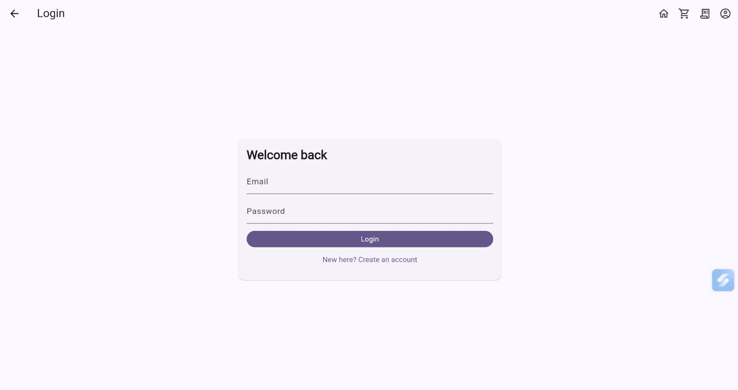
Website Screenshots

Sign In Page

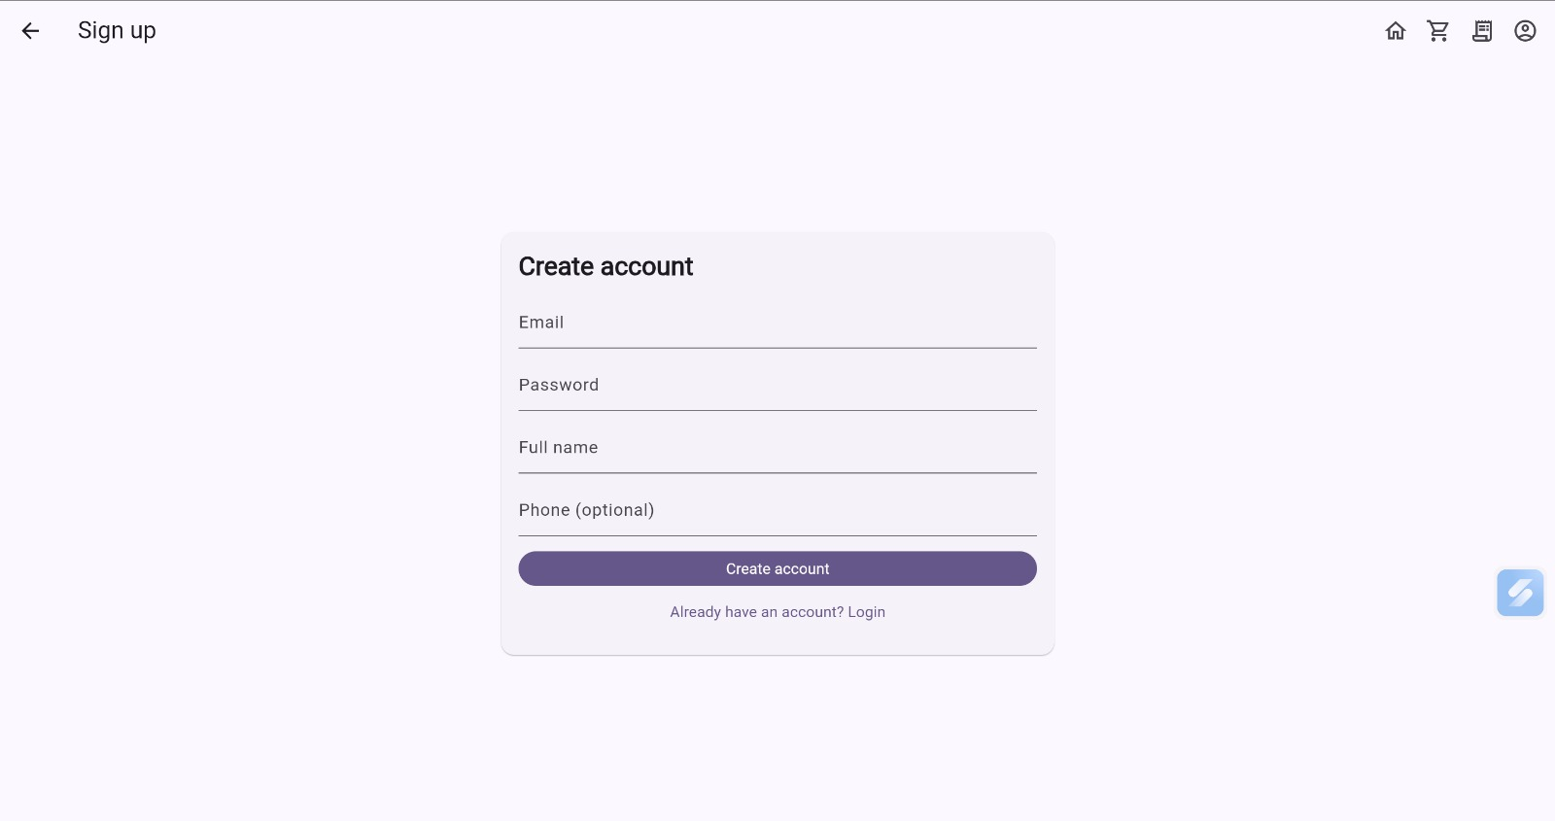
Sign Up Page

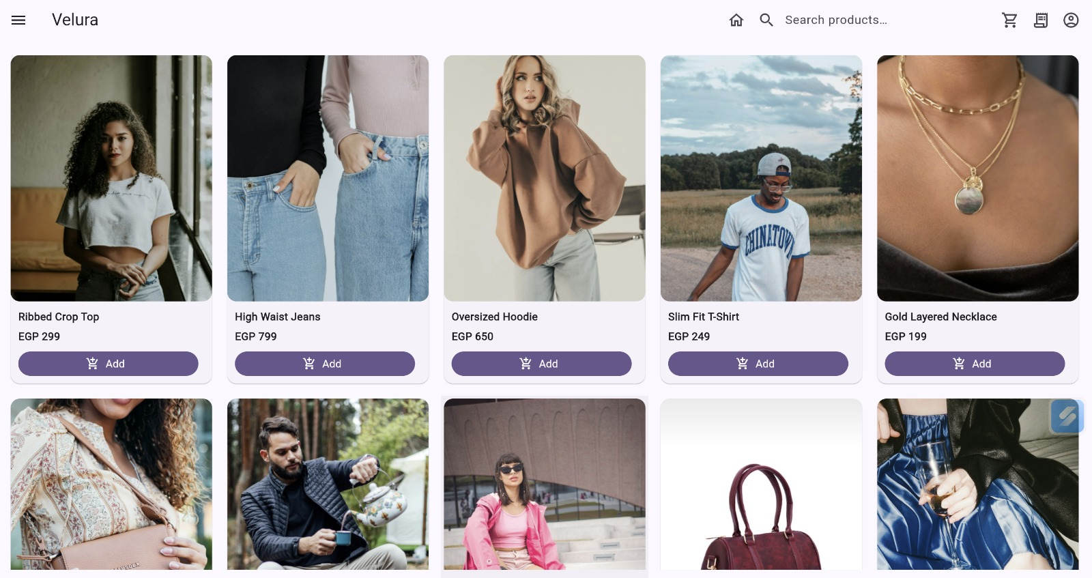
Home Page

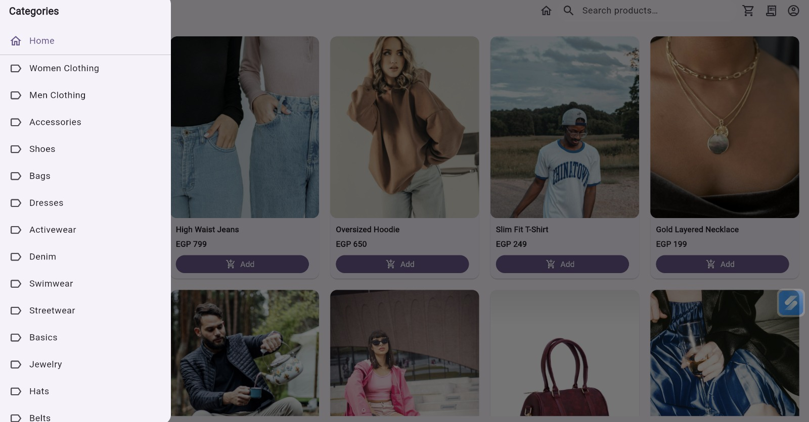
Categories
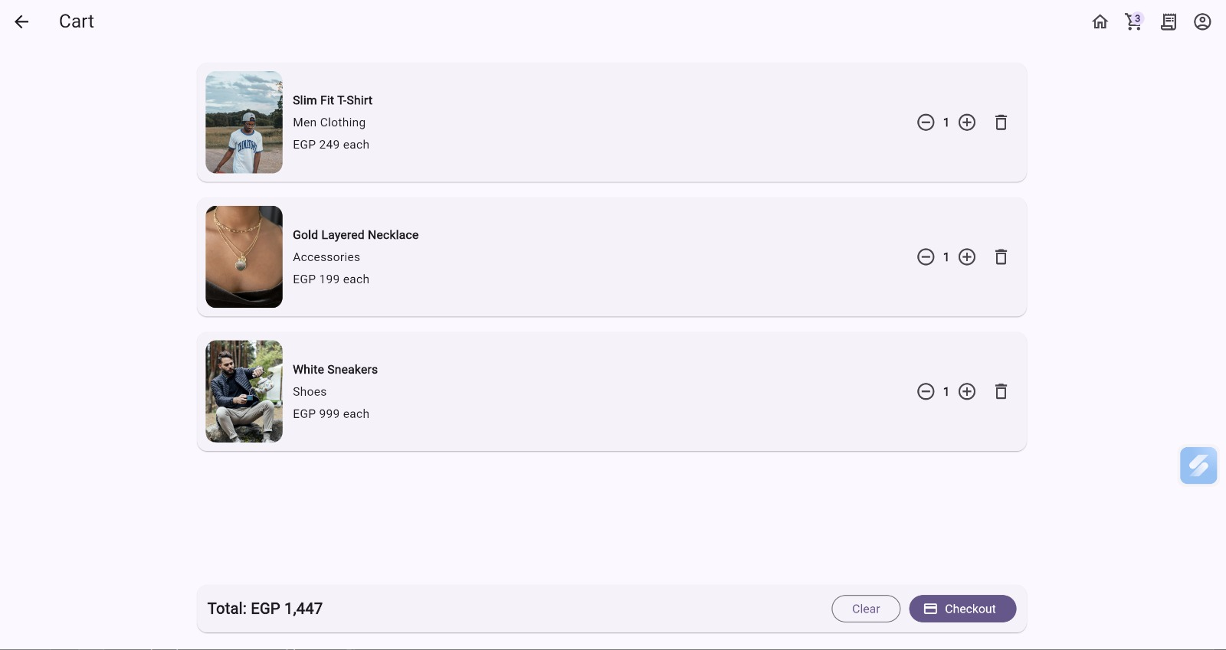
Cart
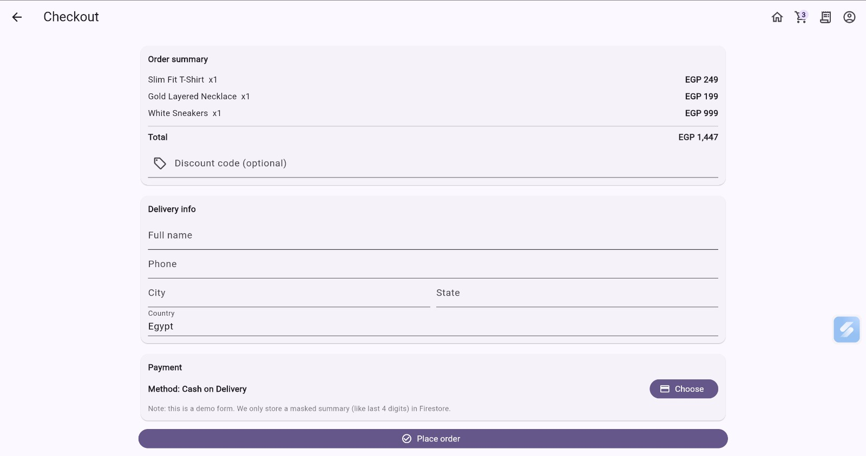
Checkout
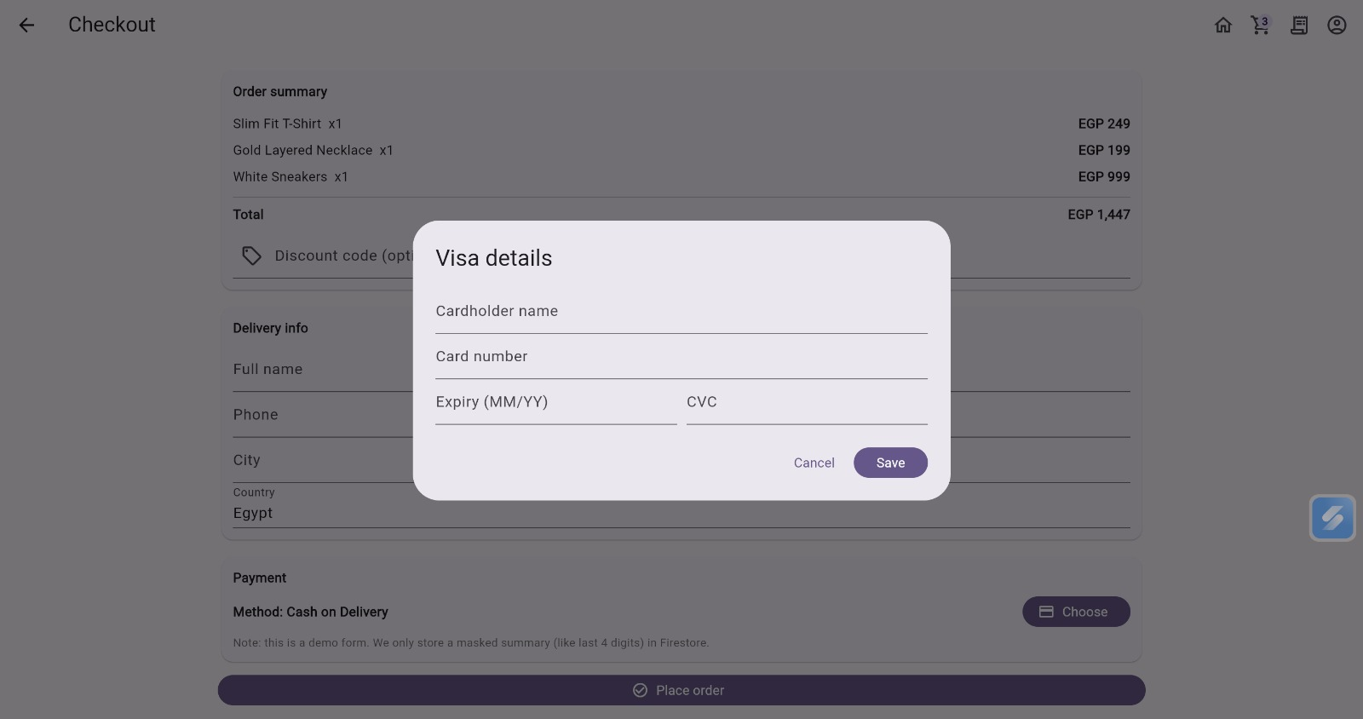
Payment method
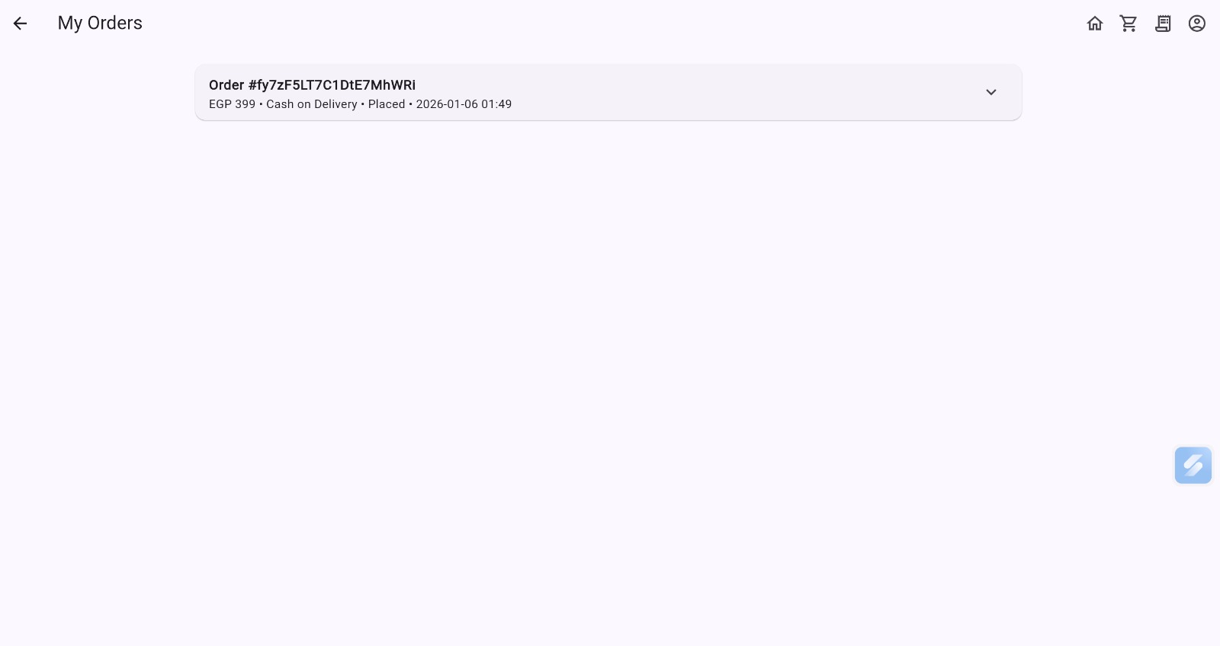
Orders

Website Testing

Manual Testing:
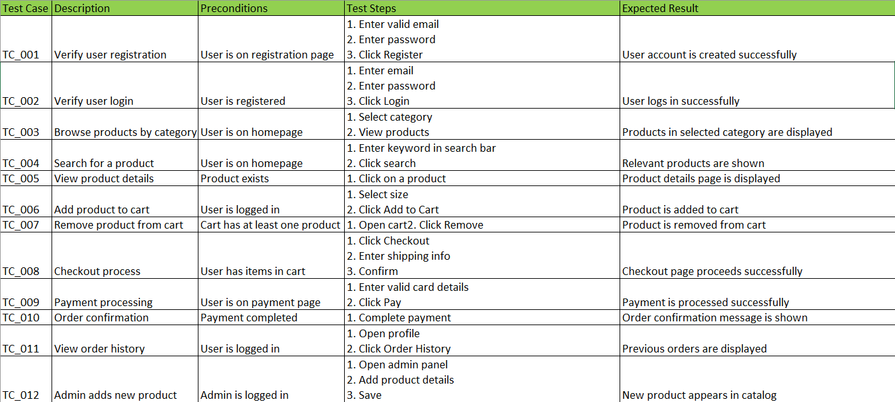

Automatic Testing:
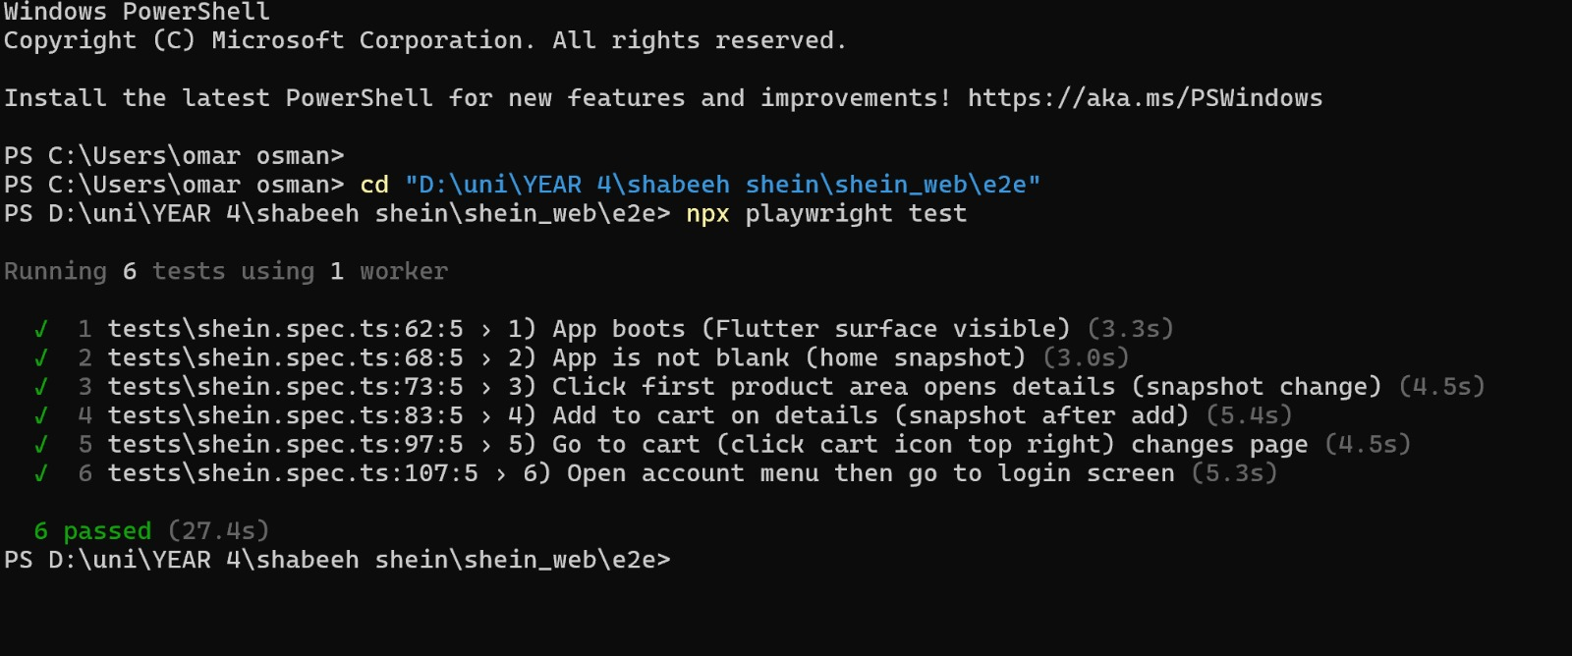

GitHub Link
Link: https://github.com/Abdelrahman-Walid-Issa/Velura

